
Unit 4 Assessment 5 - SS Evidence Collection
Rob Johnston | Deep Learning Training Project | Criteria 3.1, 3.2, 3.3

Project Context
This assessment uses Trade-A-Them as the real project context. Trade-A-Them is my active cryptocurrency trading-bot project and the public website presents it as an AI-powered crypto trading platform with machine learning, multi-engine consensus and technical trading features. The practical evidence uses safe college datasets rather than private live trading data, but the training, validation and inference workflow is the same type of workflow used when model evidence is prepared for a larger AI trading system.
The first model uses the Iris dataset because it is a clear baseline classification problem. The second model uses a Trade-A-Them-style synthetic cryptocurrency signal dataset to represent trading-signal classification safely. This avoids exposing private exchange credentials, private account data, private credentials or live trading records while still demonstrating the required deep learning skills.

Evidence Summary
Criterion | Evidence included
3.1 | Two training workflows: Iris baseline classification and Trade-A-Them-style synthetic cryptocurrency signal classification.
3.2 | Iris validation-set hyperparameter tuning using three hidden-size and learning-rate configurations.
3.3 | Inference from a saved and reloaded Iris checkpoint on a held-back example.

3.1 Iris baseline training
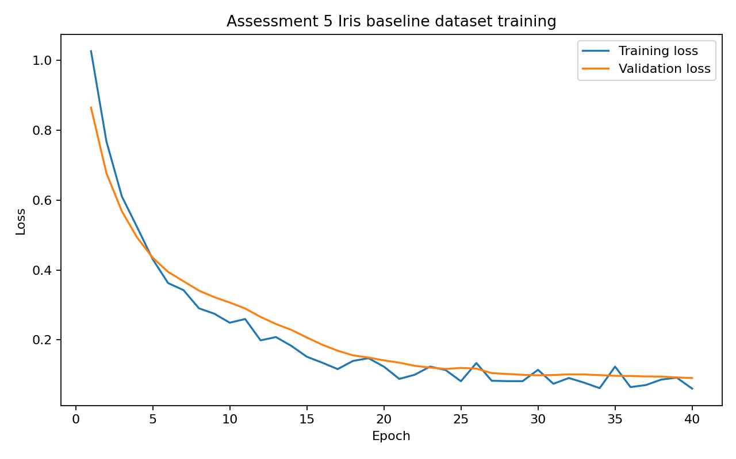
This screenshot demonstrates the first way to train a deep learning model. The Iris dataset is used as a controlled baseline because it has known input features and known target classes. The script splits the data into training, validation and test sets, scales the features, creates PyTorch DataLoaders and trains a neural network across epochs. The chart shows training loss and validation loss changing during training. This proves that the model is being trained through repeated optimiser updates rather than only described in theory.

3.1 Trade-A-Them-style synthetic crypto signal training
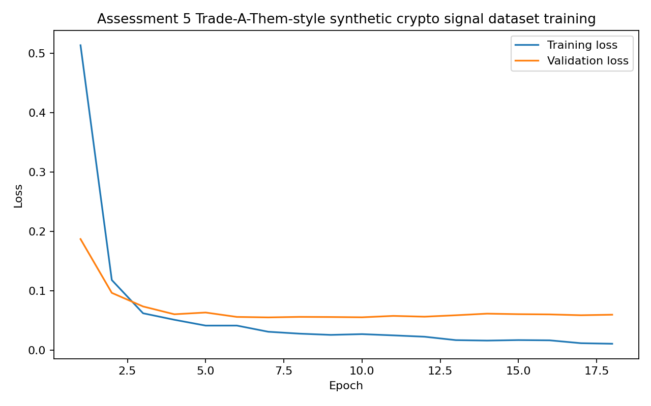
This screenshot demonstrates the second way to train a deep learning model. The dataset is synthetic, but it is framed around the Trade-A-Them cryptocurrency trading-bot context. It represents a safe classification workflow for possible trading-signal style labels such as risk exit, hold and buy signal. This keeps private trading records and exchange credentials out of the college evidence while still showing how a deep learning model can be trained on structured numerical inputs for a trading-bot style problem.

3.2 Validation-set hyperparameter tuning
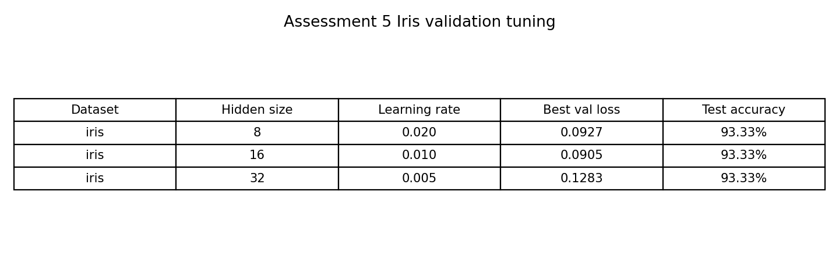
This screenshot demonstrates validation-set hyperparameter tuning. The Iris model is trained with three different hidden-size and learning-rate configurations. The validation loss is compared across the configurations and the best model is selected before the final test-set check. This matters in AI programming because a model should not be chosen only from training loss. In a Trade-A-Them style workflow, validation helps stop a model from being selected just because it fitted past data too closely.

3.3 Inference using a saved checkpoint
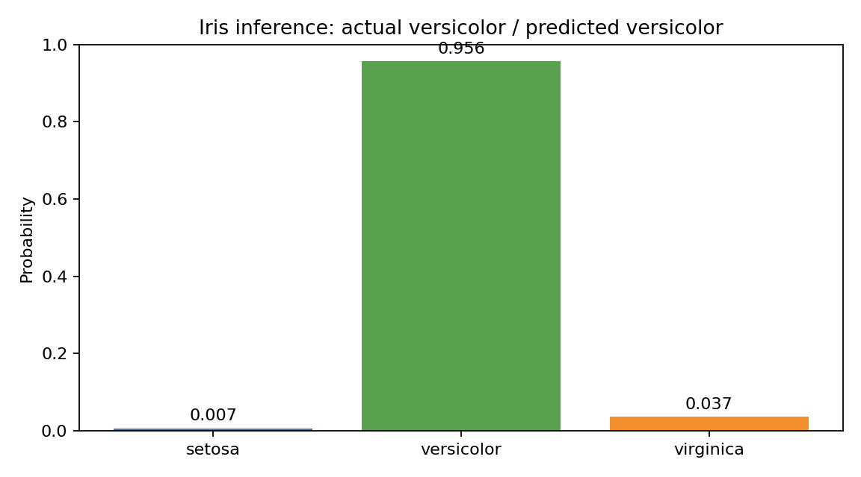
This screenshot demonstrates inference. After training, the Iris model checkpoint is saved and then loaded back into a model. A held-back Iris example is passed through the loaded model and the output probabilities are used to choose the predicted class. The actual class is versicolor and the predicted class is also versicolor. This links to the trading-bot context because inference is the stage where a trained model produces a prediction from new input data.

3.3 Held-back test-set check
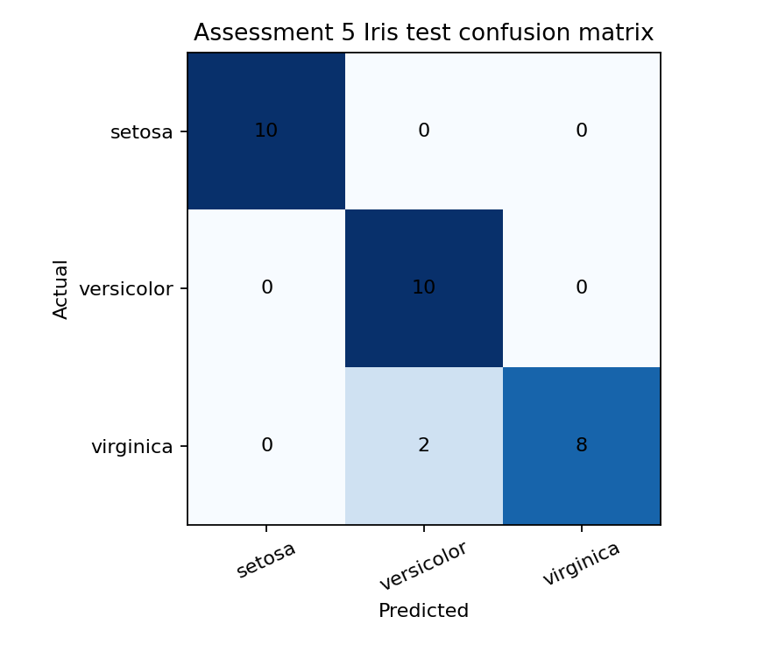
This screenshot supports the inference evidence by showing how the selected Iris model performs on the held-back test set. The confusion matrix compares actual classes against predicted classes after validation tuning has already selected the model. This gives stronger evidence than a single prediction on its own because it shows broader test behaviour. The generated summary records an Iris test accuracy of 93.33%, which supports the conclusion that the training, validation and inference workflow ran successfully.

Generated Output Files
Output | Purpose
assessment5_iris_best_model_checkpoint.pt | Saved Iris model checkpoint for loading and inference.
assessment5_tradeathem_synthetic_crypto_model_checkpoint.pt | Saved checkpoint from the Trade-A-Them-style synthetic crypto-signal training workflow.
assessment5_training_metrics.csv | Training and validation metrics across epochs.
assessment5_summary.json | Structured summary of criteria, dataset splits, tuning result and inference result.
PNG chart files | Embedded visual evidence for training, tuning, inference and testing.

References
- Trade-A-Them public website: https://www.tradeathem.co.uk/
- Trade-A-Them public features page: https://www.tradeathem.co.uk/pages/features
- Trade-A-Them public technology page: https://www.tradeathem.co.uk/pages/technology
- Local evidence source used for context: Trade-A-Them README and advanced ML predictor files. Private credentials, live exchange keys and account secrets are not included in this assessment pack.

